Good evening, esteemed members of the Zanskar Group. I am pleased to see all of you, and your enthusiasm to learn also lifts my spirits, prompting me to share more with you
If my sharing helps you all, then I believe it is worth it. Let's move on to today's discussion, where we will try to understand what a trend line is.
Trend Lines

Trendlines are custom lines drawn on price charts to connect a sequence of prices to get a likelihood of the future trajectory of the price. Trend lines are most commonly used in price charts to make it easier for traders to analyze a trend. A trendline is drawn above pivot highs (Sequence of proper higher lows) or below pivot lows (sequence of proper lower highs) to indicate the predominant price direction.
Trend lines are an essential tool used in charting and technical analysis. The least-squares method of fitting a line to the data points yields the trendline equation. The slope of the trendline indicates the strength of the trend, while the y-intercept is the starting point of the trend. The trend line graph is used to project future price movements based on historical trends. Linear trend lines are the most commonly used trend lines in technical analysis.
What is a Trend Line?

A trend line is a slanting straight line connecting two or more price points (importantly, higher lows or lower highs) and extending into the future to act as a support or resistance line. The trend line is employed to offer the trader an indication of the direction in which the price is more likely to flow. They illustrate the direction and velocity of prices. When two trendlines are created during price consolidation, it leads to the creation or observation of patterns. These patterns further amplify trading signals. Trend lines are lines drawn above or below the price at an angle. Below is a pictorial representation of the same.
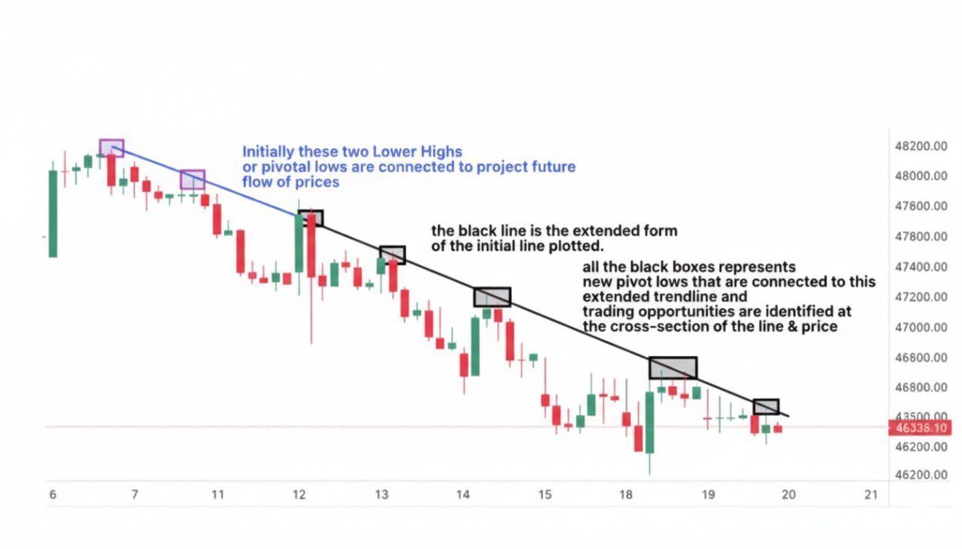In the image uploaded above, look how the extended trendline highlighted in the black color acted as the slanting resistance levels where traders could have taken this opportunity to take short trades with other confirmations.

Trend lines are used to estimate support and resistance levels in a price chart. Take a look at the picture below.
The resistance level is the reverse of the support level and represents the price level at which the financial instrument tends to encounter resistance as it increases. It’s the point at which selling pressure becomes sufficiently intense to prevent the price from rising further. In the case of trendlines, the resistance is taken at the slanting price points represented by drawn trendlines.
Trend lines are used to identify trends in different time frames, such as short-term, intermediate-term, or long-term trends. Traders often use trend lines in conjunction with other technical indicators to help identify potential buy or sell signals. But trend lines are not always precise, and traders should consider using a “best fit” approach when drawing them.
What is the Importance of a Trend Line?
Trend lines are important in the stock market because they help traders & short-term investors identify the direction of a stock’s price movement. Trend lines show whether a script/stock is in an uptrend, a downtrend, or trading sideways by connecting the highs or lows of a stock’s price over a period of time.
Let’s look at an example to understand this better. Let’s assume we are looking at the stock price movement of Reliance Industries Limited (RIL) over the past six months. We will use a daily chart to analyze the stock’s price movement.
We will connect the highs or lows of the stock’s price movement to create a trend line. We will connect the lows if the stock is in an uptrend. Take a look at the picture below.
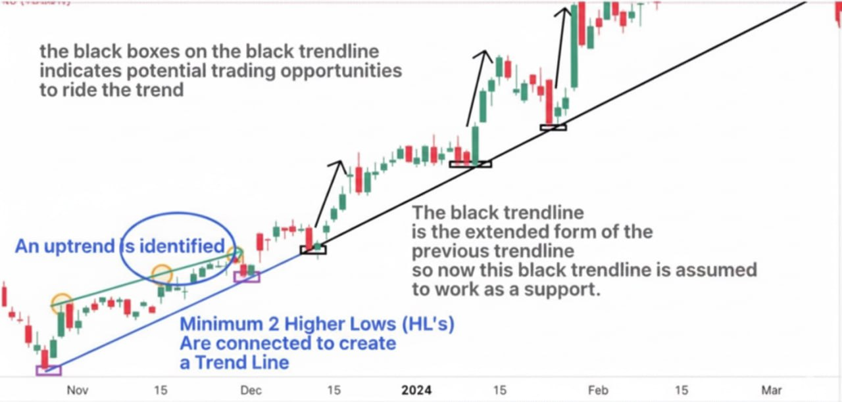
From the example posted above, one can understand how critical and important trend lines are. They work as a classic subjective tool to interpret market data, and after plotting a logical trendline, it gives a visual future predictability of how the trend is supposed to look. After combining different factors, trend lines stands out as a strong factor to validate a trading setup to initiate a trade by taking into consideration appropriate risk management.
How to Draw a Trend Line?

The first step in drawing the trend line is determining the trend. Evaluate whether the trend is an uptrend or a downtrend by examining the chart. A rising trend is marked by higher highs and higher lows, whereas a falling trend is marked by lower highs and lower lows. Let us take an example of a downward trend to understand this better.
The steps that are supposed to be followed to draw a trend line are:

1. Identify the trend of a stock. If it’s in an uptrend, it will have a series of Higher Highs and Higher Lows, which gives an interpretation that the price of the stock is in a phase of constant rise. If it's in a downtrend, as taken in the example below, Lower Lows and prominent Lower highs are identified.

2. After identifying relevant lower highs, at least 2 – 3 lower highs are connected by drawing a slanting line. This slanting line is projected onto the chart to form a defined trendline, as shown in the image below.
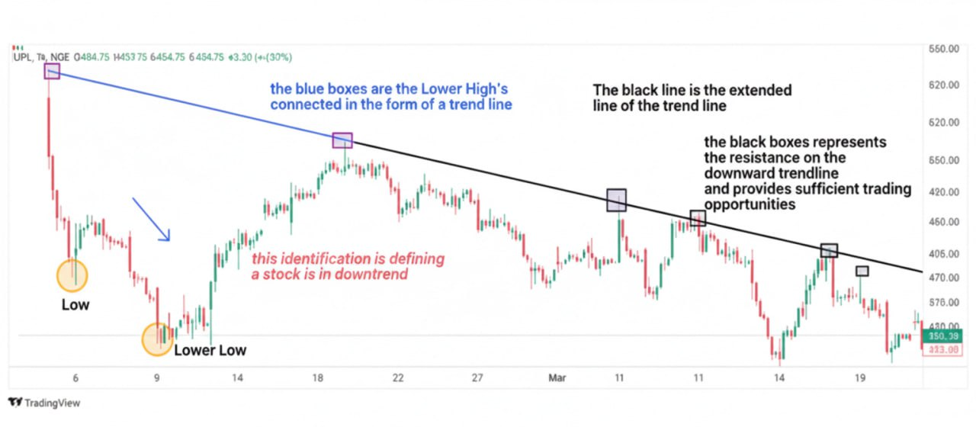
3. The trendline drawn and extended from the relevant lower highs, the price of the trendline is presumed to work as a resistance and react when the price reaches it.

4. The black boxes in the image above represent the reaction of CMP to the trendline resistance and how it further managed to create Lower lows internally.

5. The trendline has continued to act as a resistance and provided multiple trading opportunities.
Traders use this trend line as a guide when making trading decisions. Although trendlines can be drawn on all the time frames, the accuracy of the working of trendlines largely depends on how a trader identifies relevant pivot lows or pivot highs. They also work much better on higher time frames. In today’s era, market participants are heavily dependent on trendlines, thus, they should be drawn properly to avoid traps and must incorporate other tools and indicators to solidify a trading setup. Multiple trend lines during the same time period give rise to the formation of chart patterns.
What does the Trend Line Indicate?

Trend lines indicate and predict the future direction of a security’s price. A rising trend line indicates an uptrend, while a falling trend line indicates a downtrend.

Trend lines are used to identify potential entry and exit points for trades. A trader, for example, may look to buy a security when the price touches a rising trend line, or sell when the price touches a falling trend line.
What are the Advantages of a Trend Line?
Trend lines have advantages, including helping predict exit and entry points, finding support and resistance levels, etc. Below are 4 main advantages of using a trend line.

1. Trend identification
Trend lines assist traders in identifying trends in the price movement of a stock. Traders can easily determine if the stock is in an uptrend or a downtrend by linking the higher lows and lower highs of a company’s price with a line. This assists traders in making more educated judgments on the purchase or sale of the asset.

2. Identifying support and resistance levels
Traders use trend lines to establish a stock’s support and resistance levels. Support levels are the price levels at which it is anticipated that buyers will enter the market, whereas resistance levels are the price levels at which it is anticipated that sellers will enter the market. Traders detect key levels and make trading decisions based on them by connecting the pivot lows or pivot highs of a stock’s price movement with trend lines.
3. Timing entry and exit
Trend lines are used to determine entry and exit points for trading. With the help of a trendline, a trader can ride the entire trend and place trailing stop losses a few points above (if a short position is taken) or below a trendline (if a long position is taken). A trader, after validating a trading setup, can place long positions on a relevant rising trendline or vice versa.

4. Trend confirmation
Trend lines provide support for other technical indicators for trend confirmation. A trader, for instance, waits for the price to come back to the trend line before starting a long position if a company is in an uptrend and the relative strength index (RSI) indicates that circumstances are overbought.

Utilizing trend lines in combination with other technical analysis tools helps traders make informed decisions when buying or selling assets.
Due to time constraints, I will end my share here for tonight. We will continue tomorrow

